Bugzilla Defect Tracking Guidelines
Version 1.0

Issue Date: | 15 Oct 2010
Issue Status:
Owner: | ? Solutions
Author: | Giang Tran
Location: | ? SVN Repository
Confidential Class: | ? Confidential

Document Revision History
Date | Revision | Description | Revised by
15-Oct-2010 | 1.0 | First version | Giang Tran

Table of Contents
1. Introduction 4
1.1 Purpose 4
1.2 Scope 4
1.3 Definition, acronyms and abbreviations 4
1.4 Roles Definition 4
1.4.1 Reporter 4
1.4.2 Fixer 4
2. Bug Tracking System 5
2.1 Bug Life Cycle 5
2.2 State Description 6
3. Using Bugzilla 7
3.1 URL of Bugzilla 7
3.2 Login 7
3.3 Creating a new bug 8
3.3.1 Principles 8
3.3.2 Preliminaries (Mở đầu) 8
3.4 Viewing bugs report. 12
3.5 Modifying bugs report. 13
3.6 Reports 15
I. APENDIX 16
1) DEFINING BUG ROOT CAUSE 16
2) SETUP THE INFORMATION IN A PROJECT 16
3) ADMINISTRATION 16
3.1) ADD NEW PROJECT 17
3.2) CREATE GROUP 17
3.3) ASSIGN USER INTO A GROUP 17
3.4) ASSIGN A GROUP INTO A PRODUCT 18
II. FAQ 19
1) Who will submit the bug? 19
2) When a bug is changed to “closed”? 19
3) I want to access a bug list quickly. How can I do? 19
4) Many people would like to have the same search result. How can we do? 19
5) How can I reduce the number of notification email? 19
6) How can I add a defect quickly? 19

Introduction

1.1 Purpose
This guideline defines activities in reporting bugs discovered during testing workflow. The goal of this guideline is to establish a standard communication protocol between Tester and Fixer for reporting bugs, maintaining and tracking them during the life of the project.

1.2 Scope
Bugzilla will officially be used for the bug tracking system in ?.
The QC team is owner of the system and is responsible for creating the product, and grant the permission for each staff.

Definition, acronyms and abbreviations
QC | Quality Control
TL | Team Leader
PM | Project Manager
PL | Project Leader

1.4 Roles Definition

1.4.1 Reporter
The person who discovers the bug and submits it, usually the Tester or Business staff.

1.4.2 Fixer
The person who implements the work product that has the bug, usually the Developer

Bug Tracking System

2.1 Bug Life Cycle

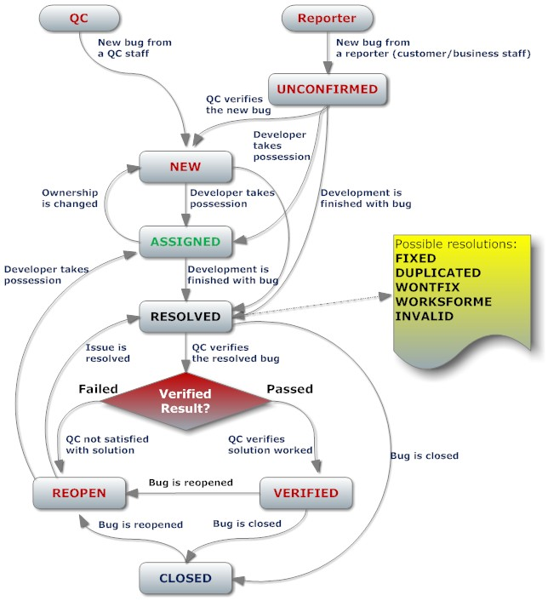

2.2 State Description
State | Description | State Transition
N/A | QC discovers and creates new bug with NEW state. | N/A | 
N/A | Reporter discovers and creates new bug with the UNCONFIRMED state. | N/A | 
UNCONFIRM | This bug has recently been added to the database. Nobody has validated that this bug is true. Users who have the "canconfirm" permission set may confirm this bug, changing its state to NEW. Or, it may be directly resolved and marked ASSIGNED or RESOLVED. | 1) UNCONFIRMED -> NEW: PL/TL/QC verifies Reporter’s bug. If it is new bug, PL/TL/QC changes its state to NEW state.  2) UNCONFIRMED -> ASSIGNED: PL/TL/QC knows full surely that this bug is new bug and assigns it to appropriate fixer.  3) UNCONFIRMED -> RESOLVED: PL/TL/QC verifies Reporter’s bug. If it is not new bug, PL/TL/QC changes its state to RESOLVED state with possible Resolution: DUPLICATE, WONTFIX, WORKSFORME, INVALID, REMIND, LATER. | 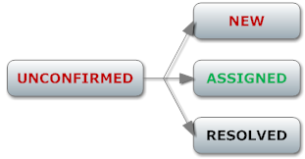
NEW | This bug has recently been added to the assignee's (default project leader, cc: test leader) list of bugs and must be processed. | 1) NEW-> ASSIGNED: PL/TL/QC accepts and assigns this bug to appropriate fixer.  2) NEW -> RESOLVED: PL/TL/QC reviews bug and marks it RESOLVED with possible Resolution:  DUPLICATE, WONTFIX, WORKSFORME, INVALID, REMIND, LATER. | 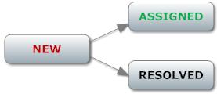
ASSIGNED | This bug is not yet resolved, but is assigned to the proper person. | 1) ASSIGNED -> NEW: Assigned fixer sends back the bug to PL/TL/QC or gives bug to another person.  2) ASSIGNED -> RESOLVED: Assigned fixer resolves bug and marks it Resolved with appropriate Resolution. | 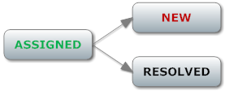
REOPEN | This bug was once resolved, but the resolution was deemed incorrect. Also, a bug is REOPENED when more information shows up and the bug is now reproducible. | 1) REOPEN -> ASSIGNED: If the bug is not assigned yet, PL/TL/QC assigns it to proper developer.  2) REOPEN-> RESOLVED: Fixer resolves bug and marks it with resolved state. | 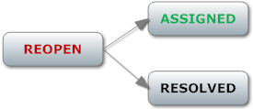
RESOLVED | A resolution has been taken, and it is awaiting verification by QC.  * Warning: Developer is not allowed to change the state of bug from Resolved into other states. | 1) RESOLVED ->CLOSED: PL/TL/QC accepts resolution (in case of DUPLICATE, WONTFIX, WORKSFORME, INVALID, REMIND, LATER).  2) RESOLVED ->VERIFIED: QC verifies and accepts resolution (in case of fixed resolution).  3) RESOLVED -> REOPEN: QC verifies and does not agree with the resolution. | 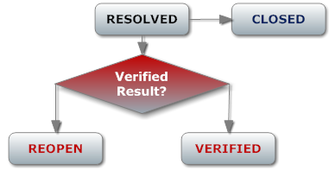
CLOSED | The bug is considered dead, the resolution is correct. Any zombie bugs who choose to walk the earth again must do so by becoming REOPENED. | CLOSED -> REOPEN:  + Regression Test: If a regression test indicates that the bug exists again, then QC changes the bug state into REOPEN. | 
VERIFIED | QC has looked at the bug and the resolution and agrees that the appropriate resolution has been taken. | 1) VERIFIED -> CLOSED: PL/TL/QC changes the bug state into CLOSED if the product against which this bug was reported actually release.  2) VERIFIED -> REOPEN: Reporter didn’t accept the fixed solution and changes the bug state into REOPENED. | 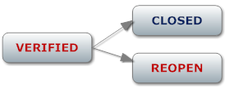

Using Bugzilla

3.1 URL of Bugzilla
You could access with URL: http://yourdomain.com/bugzilla

3.2 Login
- You can login with default username and password: (user@yourdomain.com; 123456).
- After the first login with default password, you can change password to security.
+ In the top menu, click Preferences.
+ Click Name and Password tab to change your password.
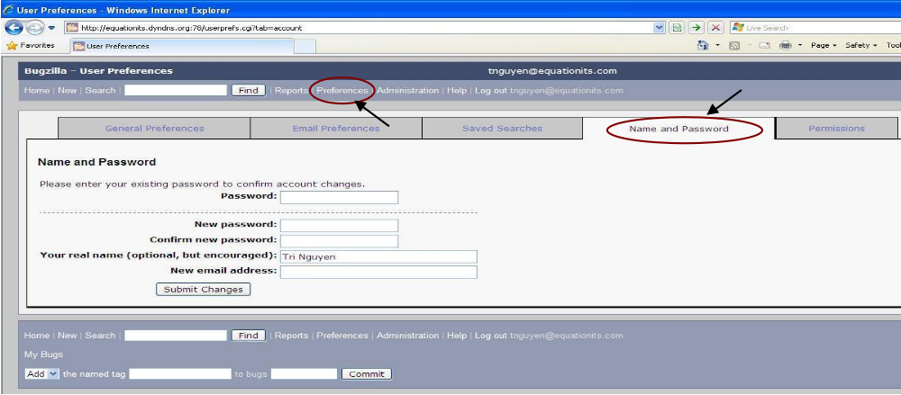

3.3 Creating a new bug

3.3.1 Principles
- Be precise
- Be clear - explain it so others can reproduce the bug
- One bug per report
- No bug is too trivial to report - small bugs may hide big bugs
- Clearly separate fact from speculation (suy đoán)

3.3.2 Preliminaries (Mở đầu)
- Reproduce your bug using a recent build of the software, to see whether it has already been fixed.
- Search Bugzilla, to see whether your bug has already been reported
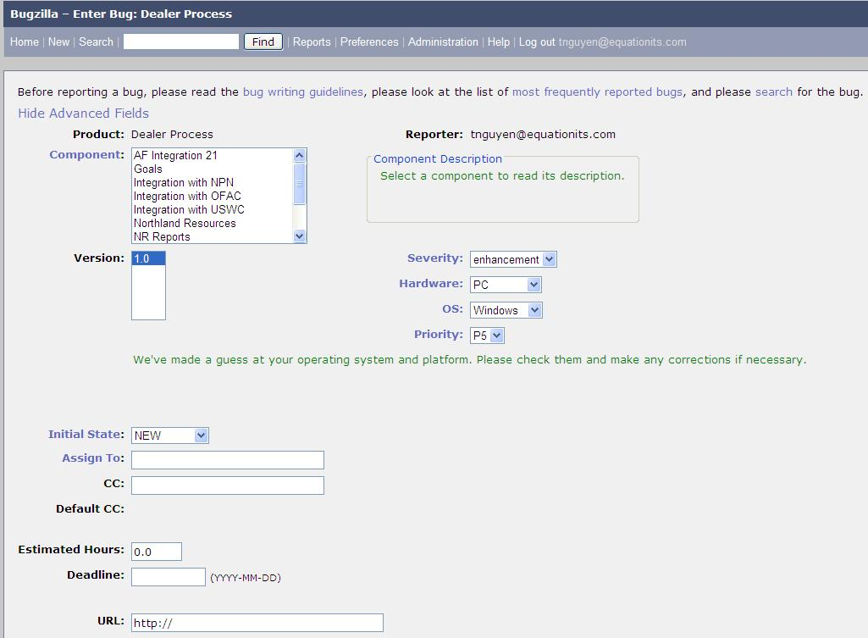
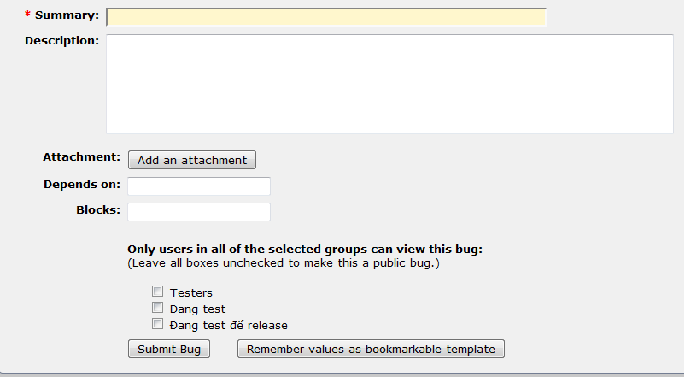

To create a new bug:
1. In the top menu, click New.
2. Product field: Select the product in which you've found the bug.
3. Component field: This field is required. Click the word "Component" to see a description of each component. If none seems appropriate, look for a "General" component.
4. Version field: If you’ve defined more than one version, choose the version from the version list.
5. Severity field: the impact or consequence of the bug to the end-user, an organization, third parties, a service, etc
Severity Values | Description
Blocker | Conditions: Prevents basic functionality of application; or blocks the internal development / testing activity (application is unusable without fix)  - 1 bug blocking large number of test cases  - SW reload / upgrade failure  - System initialization failures  - System hangs or crashes  - Local / remote login failures  - ….
Critical | Conditions: severely affect to service or application, and require immediate corrective actions:  - Security violation  - Corrupted data / configuration files  - Missing features based on roadmap  - Application or service does not work as intended; impossible to use the application or a main function of the application  - Stored data loss  - Sever memory leak  - Completely disrupt service.  - Very bad UI responsiveness making the feature unusable  - ….
Major | Conditions: seriously affect system operation, maintenance and administration, etc., and require immediate attention as viewed by the customer on discussion with the supplier. The urgency is less than in critical situations because of a lesser immediate or impending effect on system performance, customers and the customer’s operation.  - Prevention of access for system administrative activity  - Corruption of system  - Features failures under normal operations or stress conditions  - Display errors with show commands  - Poor performance with unacceptable response times  - ….
Normal | Conditions: Problems do not significantly impair the functioning of the system and do not significantly affect service to customers:  - System/Features failures caused by negative test cases or extreme stressful conditions  - Any problems which are between Major & minor severities  - High-CPU utilizations  - Performance degr?tions (serious performance degr?tion is covered in early System / Features failures caused by negative test cases or extreme stressful conditions)  A problem making a function difficult to use but no special work around is required  - ….
Minor | Conditions: A problem not affecting the actual function of the system, but the behavior is not natural  - Incorrect help/log message  - User interface layout or spelling mistake  - Cosmetic problems in the UI, other than spelling and grammatical mistakes; i.e. font sizes, placement of controls (edit boxes, list boxes, etc.) that are not hindering  - Unfriendly behavior that is merely annoying to the user  - ….
Trivial | A problem not affecting the actual function, misspelled words or misaligned text would be an example.
Enhancement | Recommended by manager and QC lead per case basis  - Nice to have feature (not in scope)  - Request for change
6. Hardware field:
7. OS field: On which operating system (OS) did you find it? (e.g. Linux, Windows XP, Mac OS X.) If you know the bug happens on more than one type of operating system, choose All. If your OS isn't listed, choose Other.
8. Priority field: the relative importance of addressing and resolving the bug. The priority will link to the severity. It has the following options:
- P1: Resolve Immediately (must be fixed before next release)
- P2: Give High Attention (Should not release without this fix)
- P3: Normal Queue (can release without, but will have to be careful who we sell to)
- P4: Low Priority (Ready for mainstream once fixed)
- P5: Nice to have

 | Always | Likely | Unlikely
Blocker | P1 | P1 | P1
Critical | P1 | P1 | P2
Major | P1 | P2 | P2
Normal | P2 | P3 | P3
Minor | P3 | P4 | P4
Enhancement | P5 | P5 | P5

Frequency: the likelihood of the bug occurring to the end-user, an organization, third parties, a service, etc.
- Always: encountered at all time
- Likely: will probably be encountered
- Unlikely: will probably not be encountered
9. Initiate State field: Refer to 2.2 State Description.
10. Assign to field: Put fixer’s email address.
11. Cc field: Put team leader/manager’s email address.
12. Estimate Hour field: Team leader puts an estimate time for fixing a bug (Optional)
13. Deadline field: Team leader/PM puts a the deadline for fixing a bug (Optional)
14. URL field: Reporter/QC puts a link to a bug page for evidence.
15. Summary field: How would you describe the bug, in approximately 60 or fewer characters?
A good summary should quickly and uniquely identify a bug report. It should explain the problem, not your suggested solution.
- Good: "Cancelling a File Copy dialog crashes File Manager"
- Bad: "Software crashes"
- Bad: "Browser should work with my web site"
16. Description field: The details of your problem report, including:
* Precondition: (Optional).
User login system successfully as admin
* Steps to Reproduce: Minimized, easy-to-follow steps that will trigger the bug. Include any special setup steps.
1. Go to manage user page
2. Click on Add user icon below user list
3. Enter valid data into all fields
4. Click Save button
* Actual Results: What the application did after performing the above steps.
1. Back to user list
2. No user is added
* Expected Results: What the application should have done, were the bug not present.
Data is saved into accurate fields and user list refresh to show new user
Build Date & Platform: Date and platform of the build in which you first encountered the bug (Optional).
Build 2006-08-10 on Mac OS 10.4.3
Additional Builds and Platforms: Whether or not the bug takes place on other platforms (or browsers, if applicable) (Optional).
Doesn't Occur On Build 2006-08-10 on Windows XP Home (Service Pack 2)
Additional Information: Any other useful information (Optional).
For crashing bugs:
- Windows: Note the type of the crash, and the module that the application crashed in (e.g. access violation in apprunner.exe).
- Mac OS X: Attach the "Crash Reporter" log that appears upon crash. Only include the section directly below the crashing thread, usually titled "Thread 0 Crashed". Please do not paste the entire log!
17. Attachment field: Attached documents or pictures which relate to bug for evidence.
Double-check your report for errors and omissions, then press "Commit". Your bug report will now be in the Bugzilla database.

3.4 Viewing bugs report.
Eventually, you’ll end up with thousands of bugs listed in your system. There are several ways to view the bugs. The easiest is to click the My Bugs link at the bottom of the page. You can also save other common searches to make life a little easier for yourself. Because we’ve only got one bug reported, we’ll use the standard Search function.
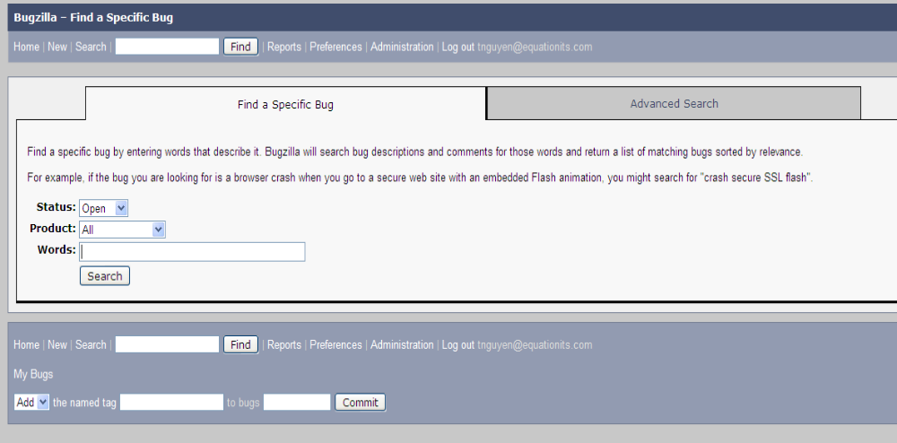

To find a bug:
1. Click Reports.
2. Click the Search link on the page, not the one in the top menu. This opens a page titled “Find a Specific Bug.”
3. Select the Status.
4. Select the Product.
5. Enter a word that you think might be in the title of the bug.
6. Click Search. If any bugs meet the criteria you entered, Bugzilla displays them in a list summary.
7. Click the ID number link to view the full bug report.

Or Advanced Search:
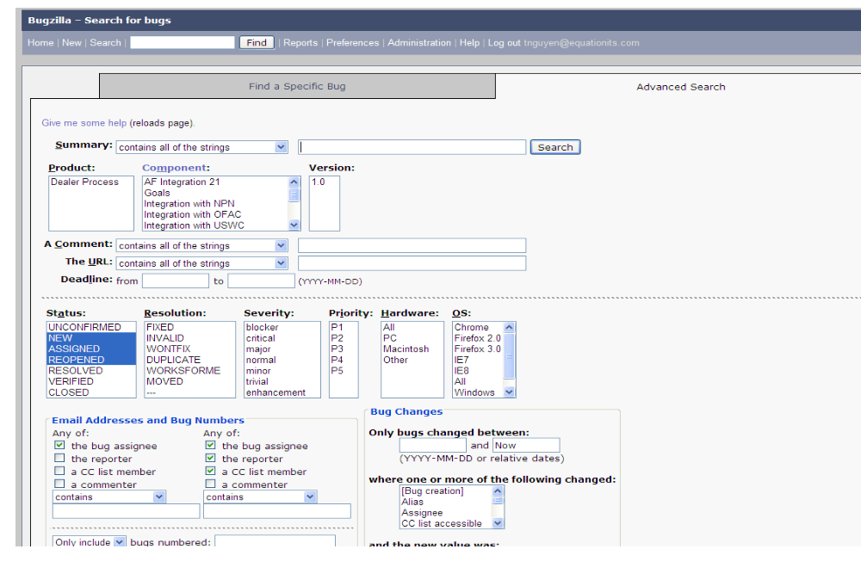

3.5 Modifying bugs report.
To modify a bug report:
1. Action field: Fixer fills out information below:
* Root Cause: Fixer puts a root cause of bug after analysis.
* Solution: Fixer puts a solution which fixes the bug.
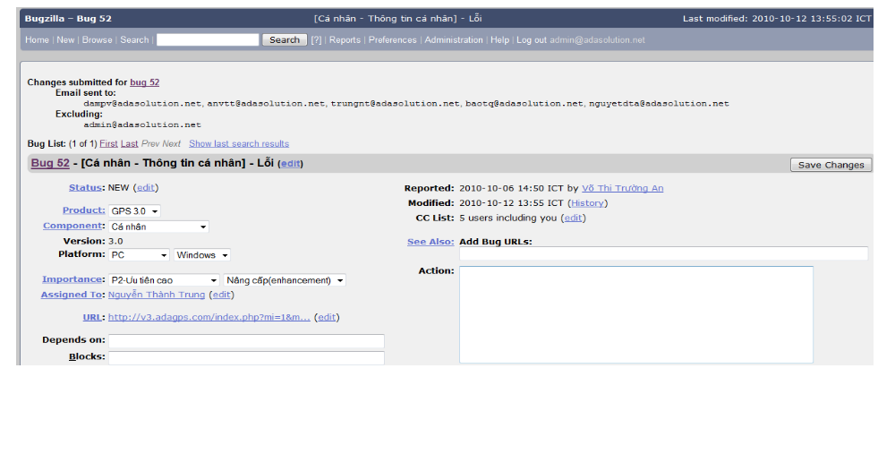

2. Additional Comments field: Scroll down the full bug description and enter a comment (Optional)
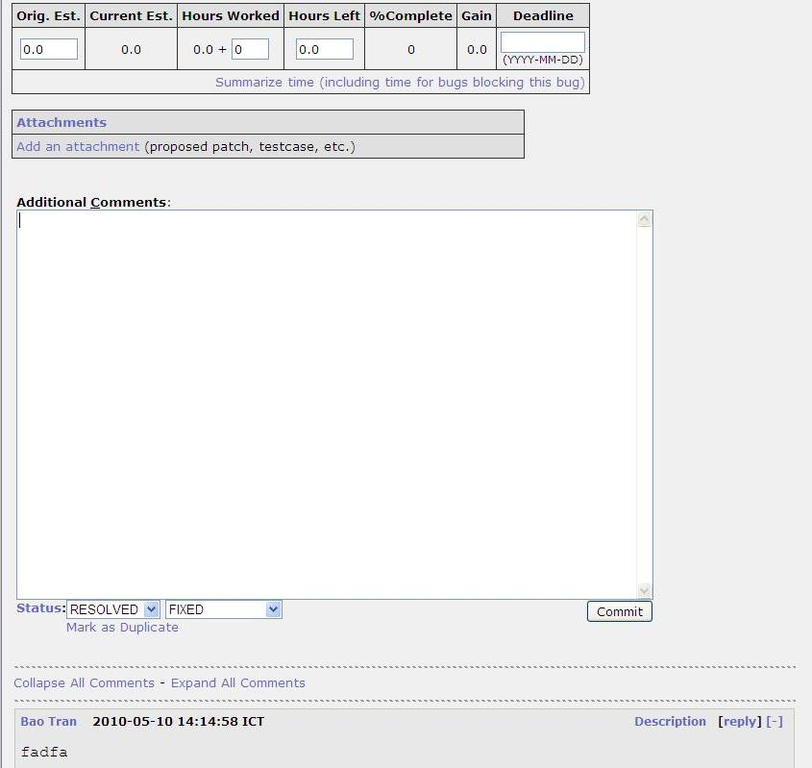

Change Status of bug
Resolution | Description
FIXED | A fix for this bug is checked into the tree and tested.
INVALID | The problem described is not a bug.
WONTFIX | The problem described is a bug which will never be fixed.
DUPLICATE | The problem is a duplicate of an existing bug. Marking a bug duplicate requires the bug# of the duplicating bug and will at least put that bug number in the description field.
WORKSFORME | All attempts at reproducing this bug were futile, and reading the code produces no clues as to why the described behavior would occur. If more information appears later, the bug can be reopened.
LATER | The problem described is a bug which will not be fixed in this version of the product
REMIND | The problem described is a bug which will probably not be fixed in this version of the product
MOVED | The problem was specific to a related product whose bugs are tracked in another bug database. The bug has been moved to that database.

- Click Commit.

3.6 Reports
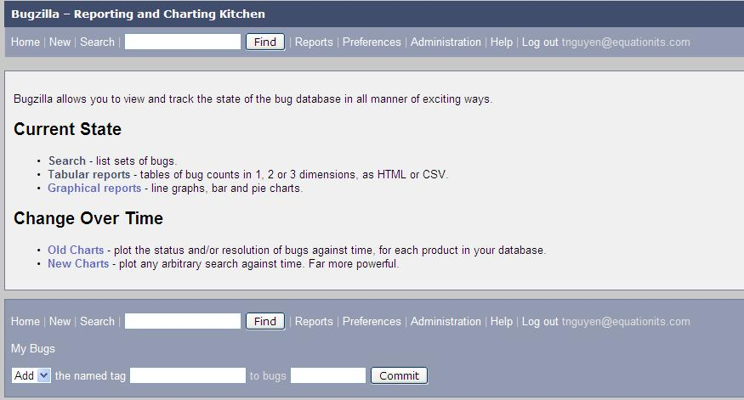

To report bugs:
1.Click Reports on the top menu.
2 Select the kinds of reports.

I. APENDIX

1) DEFINING BUG ROOT CAUSE
Basic root cause analysis can often be extremely illuminating – if 50% of your software bugs are directly attributable to poor requirements then you know you need to ﬁx your requirements speciﬁcation process.
To perform root cause analysis you need to be able capture the root cause of each bug.
A typical list of Root cause:
Classiﬁcation | Description
Requirement Issue | The bug was caused by an incomplete or ambiguous requirement with the resulting assumption differing from the intended outcome
Design Error | The design differs from the stated requirements or is ambiguous or incomplete resulting in assumptions
Code Error | The code differs from the documented design or requirements or there was a syntactic or structural error introduced during coding.
Test Error | The test as designed was incorrect (deviating from stated requirements or design) or was executed incorrectly or the resultant output was incorrectly interpreted. The bug was caused by incorrectly conﬁgured environment or data by the tester, resulting in a bug “logged in error”.
Management Issue | Mis-communication or the bugs come from the function is not ready.
Existing Bug | The bug is existing behaviour in the current software (this does not determine whether or not it is ﬁxed)

Everyone can update the root cause to have the correct value as the bug owner.

2) SETUP THE INFORMATION IN A PROJECT
Each project has specific information in Component (Module), Version. Member of each project needs to update this information.
- After logging in and going to the project, click the "Administration" link in the menu
- Click on Products
- Click on Products in the Edit products column
- Click on the “Component” or “Version” to add/update the values.

3) ADMINISTRATION
When a project needs to use Bugzilla for tracking the bugs, change request, the request will be sent to administrator of the Bugzilla. Here are the steps to add new project. It is called “product” in the Bugzilla.

3.1) ADD NEW PROJECT
- Go to administration->product
- Add new product
- Enter Project name in the Product and type something about this project in description
- Add
- Click on “Edit Component”
- Add a Component for the project. It can be “General” and select a person for “default assignee”. It can be PM of the project
- Add

3.2) CREATE GROUP
- Go to administration -> Group
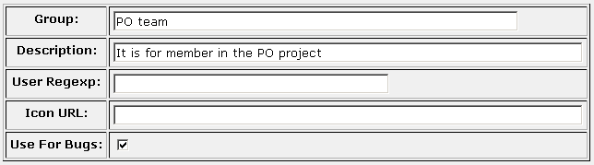
- Create a Group with project name (e.g PO team)

3.3) ASSIGN USER INTO A GROUP
- Go to administration->Users
- Search a user and go to view user who will work on the project
- Select “User is a member of these groups” checkbox for the group (e.g 2nd checkbox of the PO team)
- Save Change
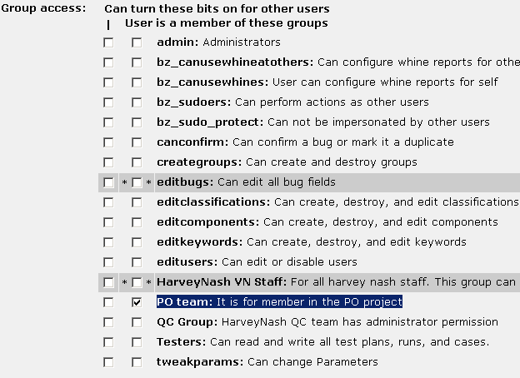

3.4) ASSIGN A GROUP INTO A PRODUCT
- Go to administration->products
- Select a product
- Click on “Edit Group Access Controls”
- Update the permission for the Group

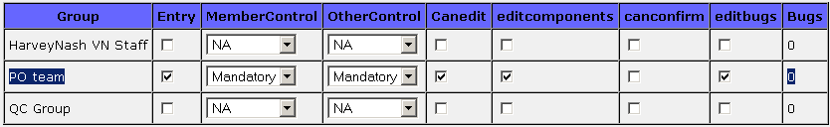
User of the group can work in the Product.

II. FAQ

1) Who will submit the bug?
Everyone can submit the defect. However, it depends on the projects assignment and the main person is usually QC member in the project.

2) When a bug is changed to “closed”?
The reporter/QC will verify the bug which status is “Ready to test”. If the bug is fixed in the package, its status will be changed to “Verified”. In the most of cases, this status is the latest status.
When a defect is reported by client and client involves in to our process. The QC will change the status of defect from “Ready to Test” to “Verified” and the client will change the status from “Verified” to “”Close” when the client verified the defect in their site.

3) I want to access a bug list quickly. How can I do?
- Go to the advanced search
- Select the search criteria and then click on search button.
- Enter the search name and click on “Remember Search” button at the end of the search result.
- The “search name” will be shown as in the bottom of the page. You can click on this link when you access to the bugzilla.

4) Many people would like to have the same search result. How can we do?
- Save your search as the previous question
- Go to Preferences->Save Searches
- It has a combo box next to each “save search” for sharing.
- Select the group which you want to share in the “Share With a Group” combo box.

5) How can I reduce the number of notification email?
The bugzilla allows user to modify the email notification setting in the “Preference”->”Email Preferences”.

6) How can I add a defect quickly?
- Go to add new defect of the selected project
- Enter all information as a template
- Click on “Remember values as bookmarkable template” button
- Store the link which bugzilla suggest. You can access to the bug template by using this link later. It will safe your time to access the “add bug” page.

